Service |  |  |  | High Availability and Disaster Recovery
System |  |  |  | Cluster and DR (Disaster Recovery) servers
Department |  |  |  | Information Technology
# | Version Type: |  | Author: |  | Version Date:
1.0 | Original Document |  | Akshay |  | 4-Aug-2024
Purpose:
This is the Standard Operating Procedure to set up Log Shipping between Clustered servers and the respective standalone DR servers.
Scope:
This document involves the systems below, and all the databases hosted over these servers are part of High Availability and Disaster Recovery.
Cluster Name | DR Server
CP02P-DSSV1 | EP02P-DVMSQL01.sunwing.local
CP02P-DSSV2 | EP02P-DVMSQL02.sunwing.local
CSAP01P-DSSV1 | ESAP01-DVMSQL03.sunwing.local
Setting Up Log Shipping in SQL Server with PowerShell Automation using dbatools
This guide will provide step-by-step instructions on how to set up log shipping in SQL Server using the PowerShell automation tool, dbatools. The script uses the Invoke-DbaDbLogShipping cmdlet with various parameters to configure and manage log shipping between a source and destination SQL Server instance.
Prerequisites
- PowerShell: Ensure we have PowerShell installed on respective servers.
- dbatools Module: Install the dbatools PowerShell module, if not installed using the command below.

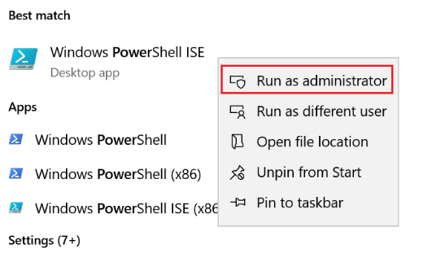
Install-Module dbatools
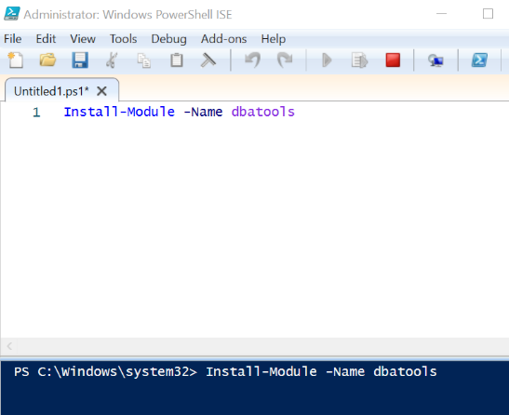
- Permissions: Ensure that we have Sysadmin permissions to configure log shipping on both the source and destination SQL Server instances.
- ADM_DBA members should have Read/Write access to premium file share
- Network Share: Ensure that the shared path is accessible from both the source and destination servers.
- Ensure that the SQL Server service account has “Storage File Data SMB Share Elevated Contributor role for premium file share” RBAC role.
Steps to Set Up Log Shipping
1. Define the Parameters
First, define the parameters required for the log shipping configuration. These parameters include details of the source and destination SQL Server instances, database names, schedule frequencies, backup options, and other necessary settings.
$params = @{
SourceSqlInstance = 'Name of the source server'
DestinationSqlInstance = 'Name of the target server'
Database = <Database Names separated by commas>
SharedPath = '\\cp02pdsacl1n001.file.core.windows.net\cp02p- dfscl1n001\LOG_SHIPPING\SharedCluster-LShipping\LS_Backups'
BackupScheduleFrequencyType = 'daily'
BackupScheduleFrequencyInterval = 1
BackupThreshold = 45
CompressBackup = $true
CopyScheduleFrequencyType = 'daily'
CopyScheduleFrequencyInterval = 1
GenerateFullBackup = $true
RestoreScheduleFrequencyType = 'daily'
RestoreScheduleFrequencyInterval = 1
RestoreThreshold = 45
RestoreAlertThreshold = 45
CopyDestinationFolder = 'Destination folder'
DisconnectUsers = $true
Standby = $true
StandbyDirectory = 'Standby folder'
Force = $true
}
3. Invoke the Log Shipping Setup
Use the Invoke-DbaDbLogShipping cmdlet with the defined parameters to set up log shipping.
Invoke-DbaDbLogShipping @params
Detailed Explanation of Parameters
- SourceSqlInstance: The name of the SQL Server instance from which the backups will be taken.
- DestinationSqlInstance: The name of the SQL Server instance where the backups will be restored.
- Database: The databases to be included in log shipping. Multiple database names should be separated by commas.
- SharedPath: The network path where the backup files will be stored.
- BackupScheduleFrequencyType: The frequency type for the backup schedule (e.g., daily, hourly).
- BackupScheduleFrequencyInterval: The interval for the backup schedule.
- BackupThreshold: The maximum allowed time (in minutes) since the last backup before an alert is raised.
- CompressBackup: Boolean value to specify if the backup should be compressed.
- CopyScheduleFrequencyType: The frequency type for the copy schedule.
- CopyScheduleFrequencyInterval: The interval for the copy schedule.
- GenerateFullBackup: Boolean value to specify if a full backup should be generated initially.
- RestoreScheduleFrequencyType: The frequency type for the restore schedule.
- RestoreScheduleFrequencyInterval: The interval for the restore schedule.
- RestoreThreshold: The maximum allowed time (in minutes) since the last restore before an alert is raised.
- RestoreAlertThreshold: The maximum allowed time (in minutes) since the last restore before an alert is raised.
- CopyDestinationFolder: The folder on the destination server where the copied log backups will be stored.
- DisconnectUsers: Boolean value to specify if users should be disconnected during restore operations.
- Standby: Boolean value to specify if the database should be left in standby mode.
- StandbyDirectory: The directory where the standby files will be stored.
- Force: Boolean value to force the operation.
Login to the server which is currently active in the cluster. We can use the query (Check Active Node from Script Library) to find out which node is active. Please refer to the screenshot below for reference.
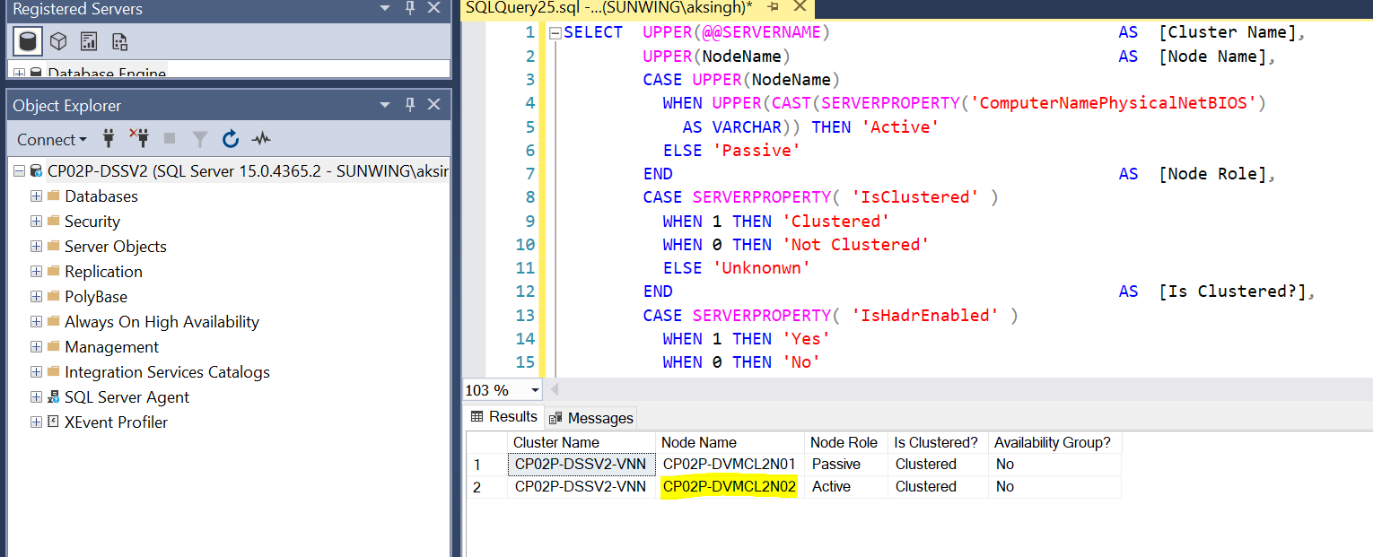
Launch the PowerShell console and edit the script as per the use case. We can include one database or more than one database. Execute the script once it is ready.
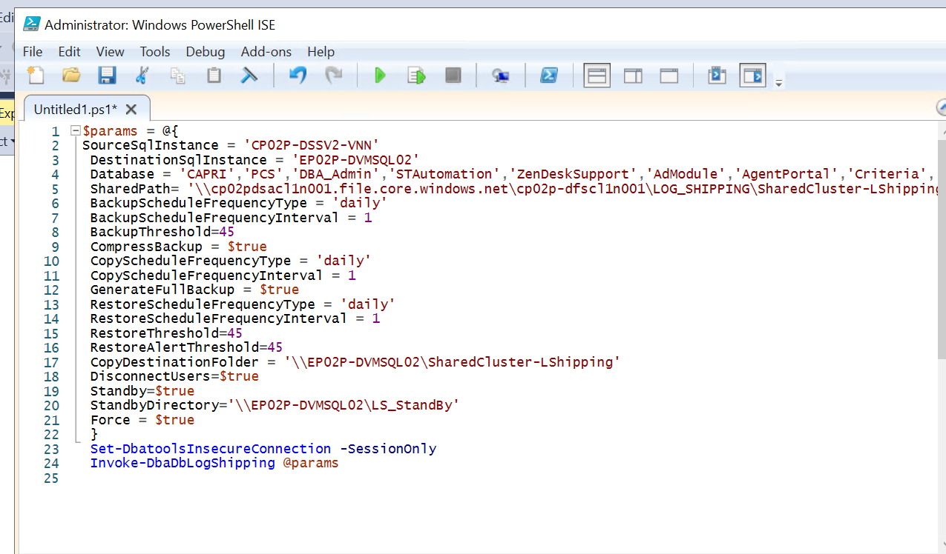
Conclusion
By following these steps, we can automate the setup of log shipping in SQL Server using PowerShell. Ensure that all parameters are correctly defined and that the necessary permissions and network paths are in place for a successful configuration.

Recovering Databases on the DR server:
1. Prerequisites
Before starting the recovery process, ensure the following prerequisites are met on the DR Server :
- PowerShell is installed on the machine where the commands will be run.
- The dbatools PowerShell module is installed. If not, we can install it using the following command:
Install-Module -Name dbatools
- DR server is properly configured for remote connections and is accessible from the primary.
Make sure we have firewall rule enabled for port 1433 from Cluster server to DR.
- ADM_DBA_Admin AD group members should have Read/Write access to premium file share
- SQL Service account must have ‘Storage File Data SMB Share Elevated Contributor’ role access on the premium file share to execute backups from SQL Server.
2. Preparing the Environment
2.1. Open PowerShell with Administrator Privileges on the DR server
2.2. Load the dbatools Module
Import-Module dbatools
3. Set Insecure Connection
To allow an insecure connection for the current session only:
>(Optional)
4. Invoke Database Log Shipping Recovery
Use the Invoke-DbaDbLogShipRecovery cmdlet to recover the databases. Replace <Servername> and <DBName> with the appropriate values.
Invoking this command will execute the copy job for the respective database, then restore job would be executed and followed by restore command WITH RECOVERY will be executed (all this happens in the background).
4.1. Example Command
Invoke-DbaDbLogShipRecovery -SqlInstance DRServer -Database MyDatabase -Verbose
5. Detailed Steps for the Recovery Process to be executed on the DR server
5.1. Open PowerShell and Set Up Environment
- Open PowerShell as Administrator.
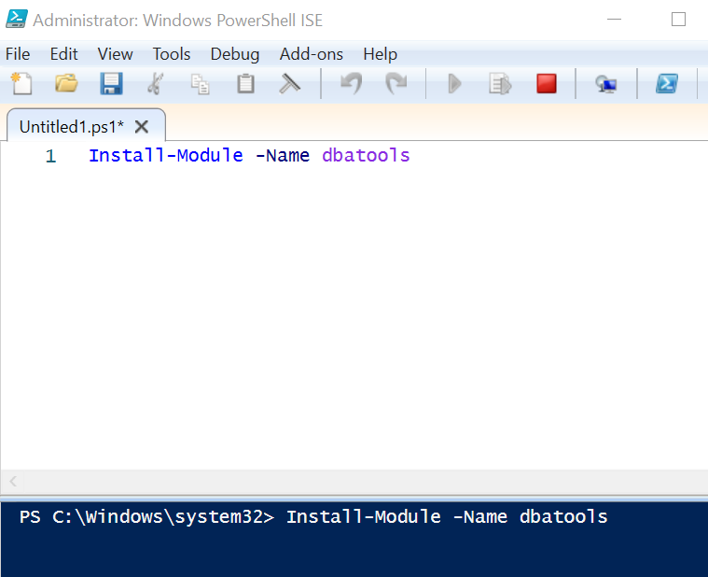
- Load the dbatools module.
5.2. Execute the Recovery Command
- Run the Invoke-DbaDbLogShipRecovery cmdlet with the necessary parameters.
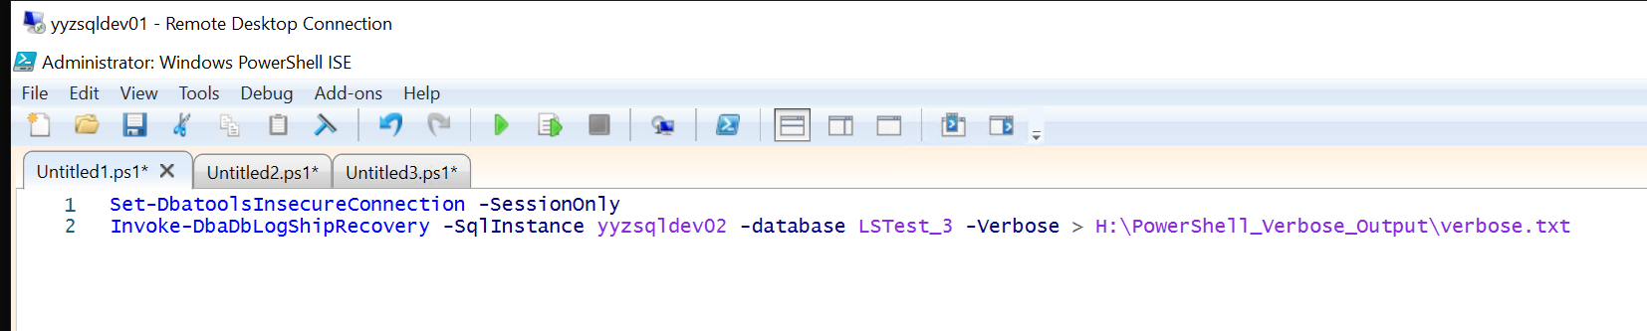
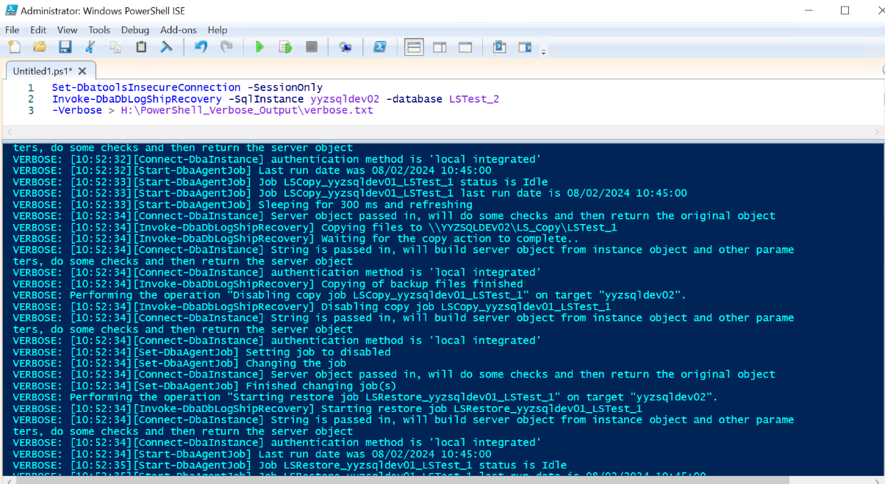
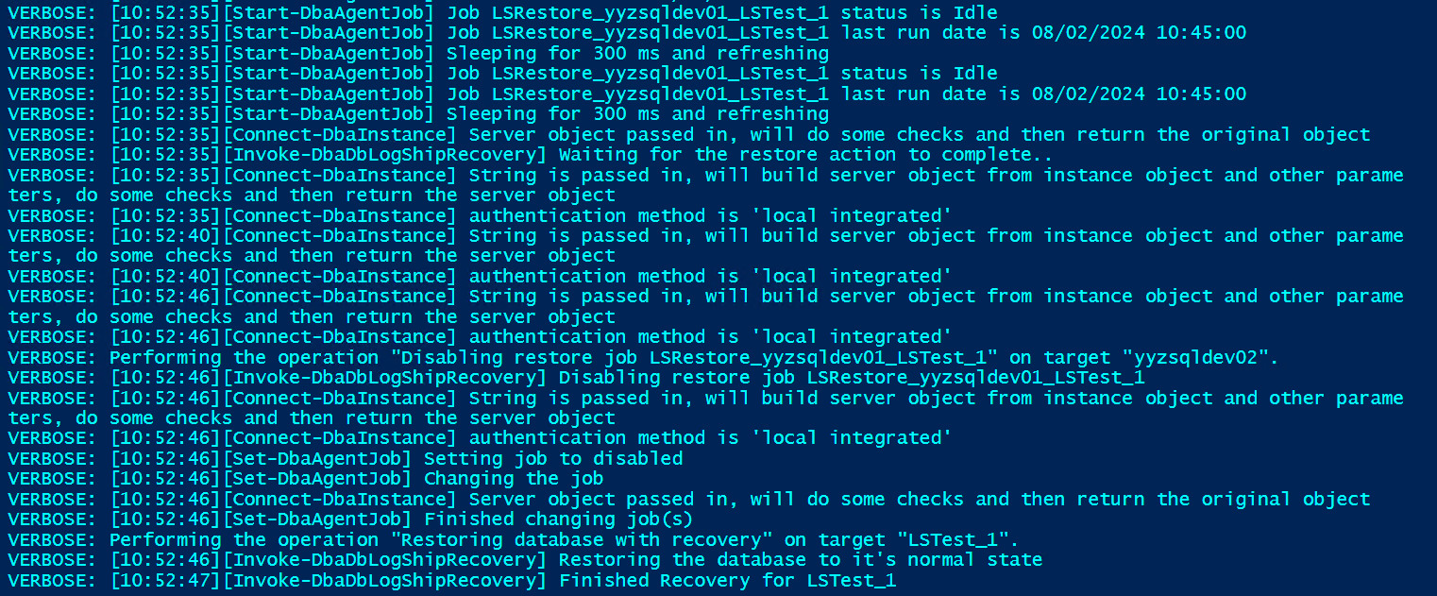

6. Monitoring and Logging
6.1. Monitor the Recovery Process
- The -Verbose parameter will provide detailed output.
- Setting up Reverse Log Shipping – Failback (from Primary (DR) to Secondary (Cluster node))
Run the same script however interchange the server's name parameters.
$params = @{
SourceSqlInstance = 'Name of the source server'
DestinationSqlInstance = 'Name of the target server'
Database = <Database Names separated by commas and enclosed within quotes>
SharedPath = '\\cp02pdsacl1n001.file.core.windows.net\cp02p- dfscl1n001\LOG_SHIPPING\SharedCluster-LShipping\LS_Backups'
BackupScheduleFrequencyType = 'daily'
BackupScheduleFrequencyInterval = 1
BackupThreshold = 45
CompressBackup = $true
CopyScheduleFrequencyType = 'daily'
CopyScheduleFrequencyInterval = 1
GenerateFullBackup = $true
RestoreScheduleFrequencyType = 'daily'
RestoreScheduleFrequencyInterval = 1
RestoreThreshold = 45
RestoreAlertThreshold = 45
CopyDestinationFolder = 'Shared Copy path' (For Example)
DisconnectUsers = $true
Standby = $true
StandbyDirectory = 'Shared Standby Path' (For Example)
Force = $true
}
In this reverse log shipping scenario (Primary = Canada East and Secondar = Canada Central), we cannot use the name or IP of the cluster server, CP02P-DSSV1-VNN (169.254.1.1), because the IP is non-routable. Therefore, we should use the shared network path for the ‘Copy’ and ‘Standby’ directories.
Additionally, since we cannot connect to CP02P-DSSV1-VNN from the DR server, EP02P-DVMSQL01, we need to use the individual node names for the connection.
Drop the databases at the new secondary (Canada Central-Cluster node) before setting up the reverse log shipping else restore will fail as log shipping will not overwrite the existing database.
Below is the fully functional command to setup reverse log shipping and for failing back to the Canada Central region:
$params = @{
SourceSqlInstance = 'EP02P-DVMSQL01'
DestinationSqlInstance = 'CP02P-DVMCL1N02' --> Check the active node before the execution of this script
Database = 'TestDB'
SharedPath= '\\cp02psacl1n001.file.core.windows.net\cp02p-dbacl1n001\Log_Shipping\DW_Cluster'
BackupScheduleFrequencyType = 'daily'
BackupScheduleFrequencyInterval = 1
BackupThreshold=45
CompressBackup = $true
CopyScheduleFrequencyType = 'daily'
CopyScheduleFrequencyInterval = 1
GenerateFullBackup = $true
RestoreScheduleFrequencyType = 'daily'
RestoreScheduleFrequencyInterval = 1
RestoreThreshold=45
RestoreAlertThreshold=45
CopyDestinationFolder = '\\cp02psacl1n001.file.core.windows.net\cp02p-dbacl1n001\Log_Shipping\DW_Cluster\Log_Shipping_Copy' # Destination Copy folder
DisconnectUsers=$true
Standby=$true
StandbyDirectory='\\cp02psacl1n001.file.core.windows.net\cp02p-dbacl1n001\Log_Shipping\DW_Cluster\Log_Shipping_Standby'
Force = $true
}
Set-DbatoolsInsecureConnection -SessionOnly
Invoke-DbaDbLogShipping @params
--Failing Back to Canada Central (Below is the fully functional command to be executed at respective Cluster Node)
Set-DbatoolsInsecureConnection -SessionOnly
Invoke-DbaDbLogShipRecovery -SqlInstance CP02P-DVMCL1N02 -Database TestDB
We can use the below script to track the recovery progress
SELECT DB_NAME(r.database_id) AS [Database Name]
,r.session_id AS [Session ID]
,r.command AS [SQL Command]
,r.STATUS AS [Status]
,CONVERT(NUMERIC(6, 2), r.percent_complete) AS [Percent Complete]
,CONVERT(VARCHAR(20), DATEADD(ms, r.estimated_completion_time, GETDATE()), 20) AS [ETA Completion Time]
,CONVERT(NUMERIC(10, 2), r.total_elapsed_time / 1000.0 / 60.0) AS [Elapsed Minutes]
,CONVERT(NUMERIC(10, 2), r.estimated_completion_time / 1000.0 / 60.0) AS [ETA Minutes]
,CONVERT(VARCHAR(1000), (
SELECT SUBSTRING(TEXT, r.statement_start_offset / 2, CASE
WHEN r.statement_end_offset = - 1
THEN 1000
ELSE (r.statement_end_offset - r.statement_start_offset) / 2
END)
FROM sys.dm_exec_sql_text(sql_handle)
)) AS [SQL Command]
FROM sys.dm_exec_requests r
WHERE command IN (
'RESTORE DATABASE'
,'BACKUP DATABASE'
,'RESTORE LOG'
,'BACKUP LOG'
);
GO

DNS also needs to be updated accordingly in case a failover occurs. We need to contact the DevOps Team for the same.

Remove Log-Shipping Configuration through PowerShell (Below is the fully functional command to be executed at respective Primary Node)
Remove-DbaDbLogShipping -PrimarySqlInstance 'CP02P-DSSV1-VNN' -SecondarySqlInstance 'EP02P-DVMSQL01' -Database 'BetaBox'

The above command will remove the log shipping jobs and will clean the metadata as well.
We can check the metadata tables below for cross verification.
On Primary Server:
Select * from msdb.dbo.log_shipping_primary_databases; -- shows record for each Log Shipped database
select * from msdb.dbo.log_shipping_primary_secondaries – shows mapping information between primary and secondary
Select * from msdb.dbo.log_shipping_monitor_primary –Shows monitor record for Primary databases
On Secondary Server:
Select * from msdb.dbo.log_shipping_secondary_databases; -- shows record for each Log Shipped database
select * from msdb.dbo.log_shipping_secondaries – shows mapping information between primary and secondary
Select * from msdb.dbo.log_shipping_monitor_secondary –Shows monitor record for Primary databases

In case if reverse log shipping is being performed then we need to do manual cleanup for couple of metadata tables to make sure there are no residual records in the metadata tables since it will break the log shipping automation setup.
While the reverse log shipping was setup, the DR was the new primary and hence the metadata table such as “msdb.dbo.log_shipping_monitor_primary” would be created in there (This table would be get created when SQL instance would act as Primary). However, this setup will not be forever, and we need to make the Canada Central as “Primary” and Canada East as “DR”.
On Secondary Server:
Select * from msdb.dbo.log_shipping_monitor_primary – this should be empty
DELETE FROM msdb.dbo.log_shipping_secondary_databases WHERE secondary_database = '<DatabaseName>';
Also, we could cross verify all the metadata tables mentioned above to make sure we have only required database’s record in the respective tables and no residual entry.

